DBMS LAB – SQL JOINS AND TRANSACTIONS

P. MADHULIKA - 2520030151
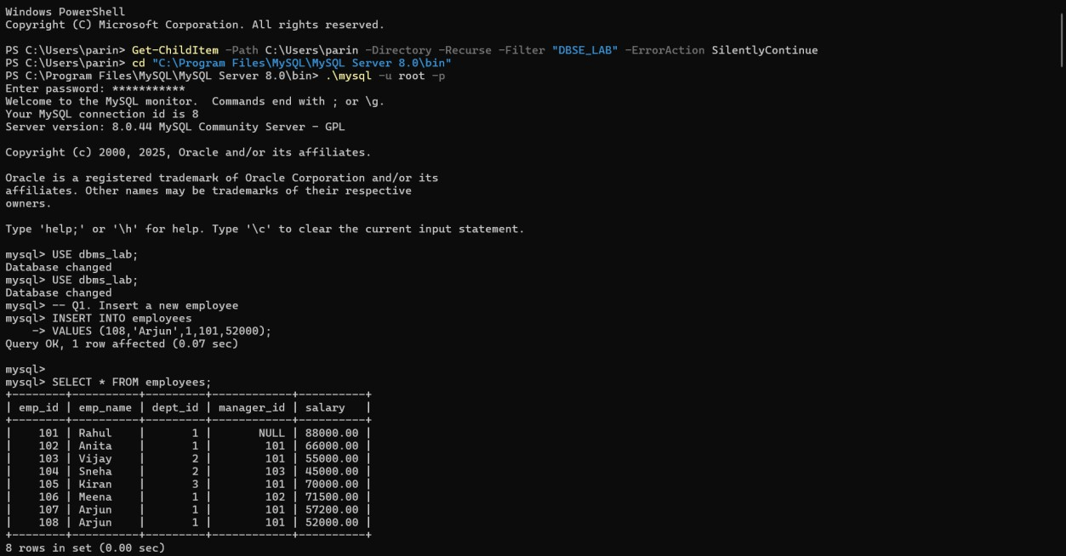


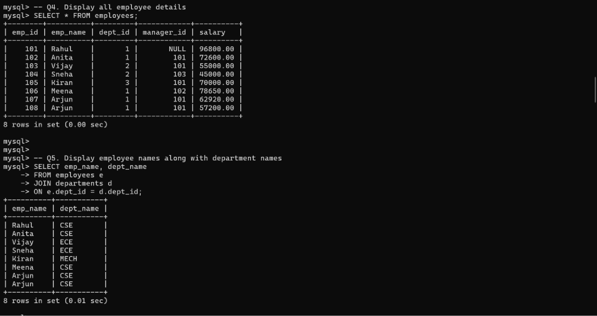
mysql>
Display employees who do not belong to any departme
mysql> -- Q6. nt
mysql> SELECT emp_name
-> FROM employees
-> WHERE dept_id IS NULL; Empty set (0.00 sec)
Display all departments even if they have no employ
mysql> mysql>
mysql> -- Q7. ees
mysql> SELECT dept_name, emp_name
-> FROM departments d
-> LEFT JOIN employees e
-> ON d.dept_id = e.dept_id;
+-----------+ +
I dept_name I emp_name I
+-----------+ +
CSE Arjun
CSE Arjun
CSE Meena
CSE Anita
CSE Rahul
ECE Sneha
ECE Vijay
MECH Kiran
Civil NULL
+-----------+ +
9 rows in set (0.00 sec)

mysql> -- QB. Display employee and manager names using SELF JOIN mysql> SELECT e.emp_name AS Employee,
-> m.emp_name AS Manager
-> FROM employees e
-> LEFT JOIN employees m
-> ON e.manager_id = m.emp_id;
+----------+ +
I Employee I Manager I
+----------+ +
Rahul NULL
Anita Rahul
Vijay Rahul
Sneha Vijay
Kiran Rahul
Meena Anita
Arjun Rahul
Arjun Rahul
+----------+ +
8 rows in set (0.00 sec)
mysql> mysql>
mysql> -- Q9. Find the total number of employees mysql> SELECT COUNT(•) AS TotalEmployees
-> FROM employees;
+ +
I TotalEmployees I
+ +
a I
+ +
1 row in set (0.01 sec)

mysql> -- Q10. Find department-wise average salary mysql> SELECT dept_name,
-> AVG(salary) AS AverageSalary
-> FROM employees e
-> JOIN departments d
-> ON e.dept_id = d.dept_id
-> GROUP BY dept_name;
+-----------+ +

I dept_name I AverageSalary I
+-----------+ +
I CSE 73634.000000 I
I ECE 50000.000000 I
I MECH 70000.000000 I
+-----------+ +
3 rows in set (0.00 sec)
mysql> mysql>
mysql> -- Qll. Display departments where average salary exceeds 6
0000
mysql> SELECT dept_name,
-> AVG(salary) AS AverageSalary
-> FROM employees e
-> JOIN departments d
-> ON e.dept_id = d.dept_id
-> GROUP BY dept_name
-> HAVING AVG(salary) > 60000;
+-----------+ +

I dept_name I AverageSalary I
+-----------+ +
I CSE 73634.000000 I
I MECH 70000.000000 I
+-----------+ +
2 rows in set (0.00 sec)

mysql> -- Ql2. Display the highest and lowest salary mysql> SELECT MAX(salary) AS HighestSalary,
-> MIN(salary) AS LowestSalary
-> FROM employees;
+---------------+ +
I HighestSalary I LowestSalary I
+---------------+ +
96800.00 I us000.00 I
+---------------+ +
1 row in set (0.00 sec)

mysql> mysql>
mysql> -- Q13. Display employees earning more than the averages lary
mysql> SELECT emp_name, salary
-> FROM employees
-> WHERE salary > (
-> SELECT AVG(salary)
-> FROM employees
-> );
+----------+ +
I emp_name I salary
+----------+ +
Rahul 96800.00
Anita 72600.00
Kiran 70000.00
Meena 78650.00
+----------+ +
4 rows in set (0.00 sec)
mysql> mysql>
mysql> -- Q14. Find employees working in the same department as ahul
mysql> SELECT emp_name
-> FROM employees
-> WHERE dept_id = (
-> SELECT dept_id

Q20. Display the top-selling product
Cannot execute because Products and Order Details tables are not provided in the supplied manual.
Find departments with the maximum number of employ
mysql> mysql> mysql> mysql> mysql>
mysql> -- Q21. ees
mysql> SELECT dept_name,
-> COUNT(*) AS EmployeeCount
-> FROM employees e
-> JOIN departments d
-> ON e.dept_id = d.dept_id
-> GROUP BY dept_name
-> ORDER BY EmployeeCount DESC
-> LIMIT 1;
+-----------+ +
I dept_name I EmployeeCount I
+-----------+ +
I CSE 5 I
+-----------+ +
1 row in set (0.00 sec)
mysql> mysql>
mysql> -- Q22. Display monthly sales using window functions mysql> SELECT MONTH(order_date) AS Month,
-> SUM(total_amount) AS MonthlySales
-> FROM orders
-> GROUP BY MONTH(order_date);
+-------+ +
I Month I MonthlySales I
+-------+ +
a I gs00 .00 I
+-------+ +
1 row in set 0.00 sec

mysql> -- Q23. Rank customers based on total purchase amount mysql> SELECT customer_name,
-> SUM(total_amount) AS TotalPurchase,
-> RANK() OVER (
-> ORDER BY SUM(total_amount) DESC
-> ) AS CustomerRank
-> FROM customers c
-> JOIN orders o
-> ON c.customer_id = o.customer_id
-> GROUP BY customer_name;
+---------------+---------------+ +
I customer_name I TotalPurchase I CustomerRank I
+---------------+---------------+ +
I Arun 5000.00 I 1 I
I Pooja 2500.00 I 2 I
I Ravi 2000.00 I 3 I
+---------------+---------------+ +

3 rows in set (0.00 sec)
mysql> mysql>
mysql> -- Q24. Display employees whose salary is greater than the ir manager's salary
mysql> SELECT e.emp_name AS Employee,
-> e.salary AS EmployeeSalary,
-> m.emp_name AS Manager,
-> m.salary AS ManagerSalary
-> FROM employees e
-> JOIN employees m
-> ON e.manager_id = m.emp_id
-> WHERE e.salary > m.salary;
+----------+----------------+---------+ +
I Employee I EmployeeSalary I Manager I ManagerSalary I
+----------+----------------+---------+ +
I Meena 78650.00 I Anita 72600.00 I
+----------+----------------+---------+ +
1 row in set (0.00 sec)
SELECT email,
->
COUNT(*) AS Total
-> FROM users
-> GROUP BY email
-> HAVING COUNT(*) > 1;
Empty set (0.06 sec)
mysql>
HAVING
Find duplicate email addresses
mysql> -- Q25.
using GROUP BY and

